Hong Kong Exchanges and Clearing Limited and The Stock Exchange of Hong Kong Limited make no responsibility for the contents of this announcement, make no representation as to its accuracy or completeness and expressly disclaim any liability whatsoever for any loss howsoever arising from or in reliance upon the whole or any part of the contents of this announcement.

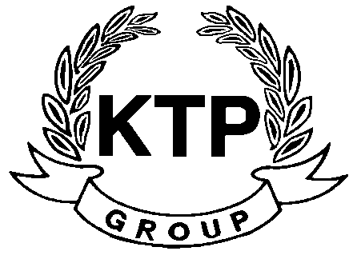
KTP HOLDINGS LIMITED
(Incorporated in Bermuda with limited liability)
(Stock code: 645)

Suspension of Trading

As the request of KTP Holdings Limited (the “Company”), trading in the shares of the Company will be suspended with effect from 12:00 p.m. today (13 December 2010) pending the release of an announcement in relation to information which is price sensitive.

As at the date of this announcement, the Board is comprised of 5 Directors, of which Mr. LEE Chi Keung, Russell and Miss. YU Mee See, Maria are executive Directors, Mr. NG Wai Hung, LEE Siu Leung and Mr. YUEN Sik Ming are independent non-executive Directors.

By Order of the Board
KTP Holdings Limited
Lee Chi Keung, Russell
Chairman

Hong Kong, 13 December 2010

